**DAILY ONLINE ACTIVITIES SUMMARY**

|  |  |  |  |  |  |  |  |  |
| --- | --- | --- | --- | --- | --- | --- | --- | --- |
| **Date:** | **29/07/2020** | | | | | **Name:** | **Spoorthy Balaji** | |
| **Sem & Sec** | **6th & B** | | | | | **USN:** | **4al17cs098** | |
| **Online Test Summary** | | | | | | | | |
| **Subject** | | **OR IA Module 4** | | | | | | |
| **Max. Marks** | | **30** | | **Score** | | | **-** | |
| **Certification Course Summary** | | | | | | | | |
| **Course** | **Introduction to CSS3** | | | | | | | |
| **Certificate Provider** | | | **Coursera** | | **Duration** | | | **4 Weeks** |
| **Coding Challenges** | | | | | | | | |
| **Problem Statement: Python Program for Number of stopping station problem** | | | | | | | | |
| **Status: Solved** | | | | | | | | |
| **Uploaded the report in Github** | | | | | **yes** | | | |
| **If yes Repository name** | | | | | <https://github.com/spoorthybalaji/Daily_Status> | | | |
| **Uploaded the report in slack** | | | | | **yes** | | | |

**ONLINE COURSE**

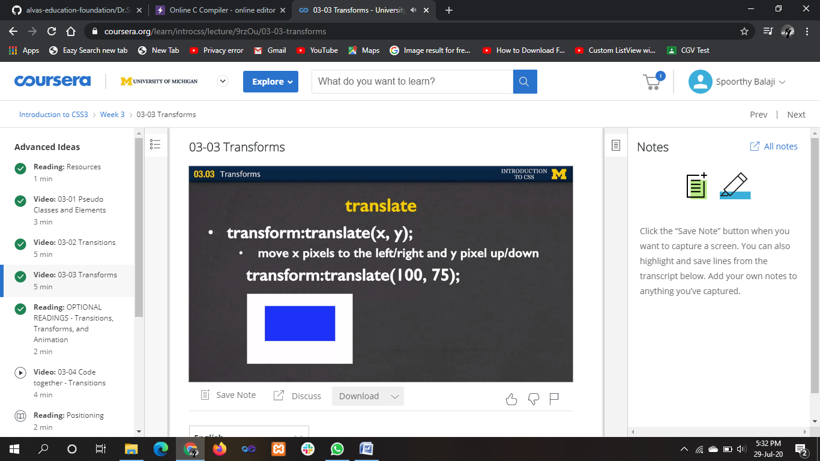

**ONLINE** **CODING**

**Python Program for Number of stopping station problem**

def stopping_station( p, n):

num = 1

dem = 1

s = p

while p != 1:

dem *= p

p-=1

t = n - s + 1

while t != (n-2 * s + 1):

num *= t

t-=1

if (n - s + 1) >= s:

return int(num/dem)

else:

return -1

num = stopping_station(2, 12)

if num != -1:

print("Number of stopping stations:",num)

else:

print("I'm Possible")

